https://eepurl.com/iB2Ofw

**[Subscribe](http://eepurl.com/iBM1jQ)**

**[Past Issues](https://us21.campaign-archive.com/home/?u=9574793ff59fab44572c66fb4&id=94c9e598ec)**

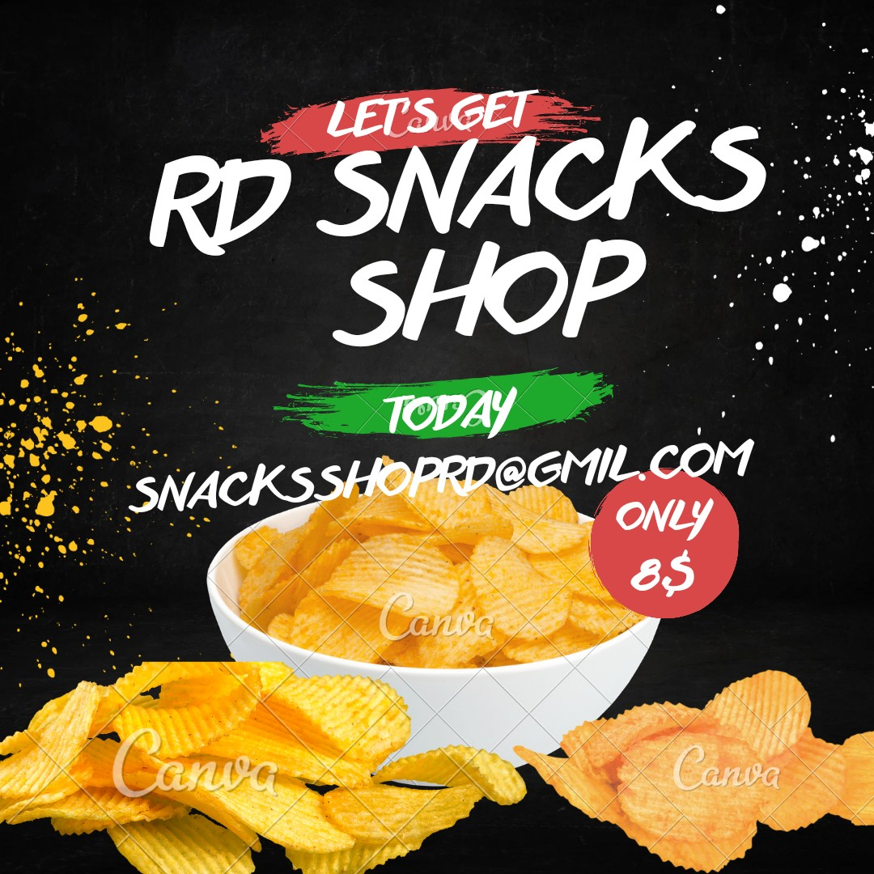

RD snacks Shop

Fresh or garden berries with cottage cheese Banana slices with peanut butter

Fresh fruit skewers with Greek yogurt

Canned fruit such as peaches orvpears with yogurt

[Snacksshopr](mailto:Snacksshoprd@gmail.com)[d@gmail.com](mailto:d@gmail.com)



*Copyright (C) *|CURRENT_2003* *|LIST:RD snacks Shop *. All rights reserved.*

Our mailing address is:

Want to change how you receive these emails? You can [u pdate your preferences](https://gmail.us21.list-manage.com/profile?u=9574793ff59fab44572c66fb4&id=94c9e598ec&e=%5BUNIQID%5D&c=33c5ff36b2) or [u nsubscribe](https://gmail.us21.list-manage.com/unsubscribe?u=9574793ff59fab44572c66fb4&id=94c9e598ec&e=%5BUNIQID%5D&c=33c5ff36b2)

